**110. How many instances of Service should it be:**

* -: In the last lecture, we set up our account service and hooked it up in our app, and still our app seems to be broken.
* If I click these buttons, the status has not changed.
* So somehow our code is not working.
* Actually, it's working correctly.
* We're just using services wrong here.
* In this specific case, we're not using the service in the way we should use it in our app.
* What's going wrong? ***The Angular dependence injector actually is a hierarchical injector.***
* *That means that if we provide a service in some place of our app, let's say on one component, the Angular framework knows how to create an instance of that service for this component, and, important, all its child components.*
* And actually, this component and all its child components, and the child components of the child components, will receive the same instance of the service.
* There are other places where we can provide a service too.
* *The highest possible level is the AppModule.*
* We haven't done this yet, but we will see this soon, if we provide a service there, the AppModule does have a provider's array.
* *The same instance, and that's important, the same instance of the class of the service is available in our whole app, in all components, in all directives, in all other services where we maybe inject the service.*
* Yes, we can inject services into services.

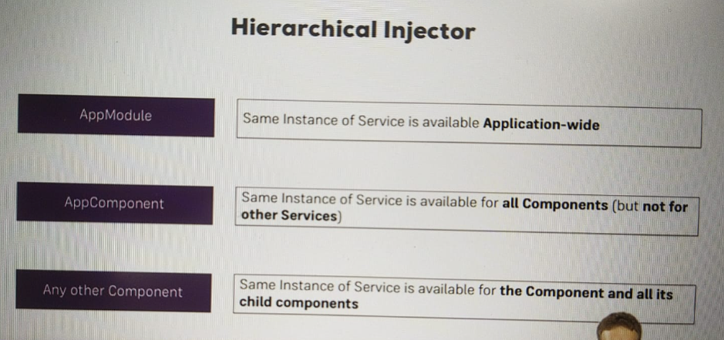

* I'll come back to this.
* The next level, for example, would be the AppComponent.
* There, the AppComponent and all its child components, do have the same instance of the service.
* And this is true for any component.
* So even if we have a child of the AppComponent, if we provide it on that child, all the children of this child will have the same instance, and the child itself, but not the AppComponent.
* The instances don't propagate up.
* They only go down that tree of components.
* The lowest level, therefore, is a single component with no child components.
* If we provide a service there, this component will have its own instance of the service, and.
* Well, it doesn't have any child components, so this instance will only be available for this component.
* And this will actually even override if we were to provide the same service on a higher level.
* And that's exactly what we're doing.
* So let's take a closer look in the next lecture.